ALABAMA SURFACE MINING COMMISSION

PERMIT APPLICATION

INDEX GUIDE

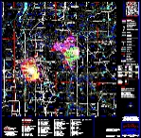
Permit Map
Birmingham Coal & Coke Co., Inc.

Bear Creek Mine

ASMC Permit Number: P-3831, R-11
Part I Administrative
A. Identification
- Ownership and Control
- Property Ownership, Interests and Rights
- Permit Area Information

Part II Environmental Resources Information

Part III Operation and Engineering

Part IV Reclamation Plan

Part V Bonding
Part VI Verification of Permit Application

